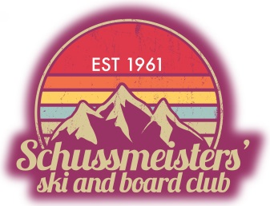

January 16, 2023

In collaboration with the Special Olympics, and Mt Holly Resort, the Schussmeisters’ of Michigan are pleased to announce the 3rd Annual Henry Walder Memorial Race – a charity benefit. This event’s primary objective is to raise funds that will allow Special Olympians to attend national events.

This all age event will be held on March 5th, 2023 at Mt. Holly. Skiers of all ages will compete and optionally collect pledges. Racers will compete for awards and in some cases (Pro division) cash prizes. Skiers who collect funds will be rewarded with perks including donated prizes such as lift tickets.

Additionally, we are reaching out to local corporate leaders with an invitation to donate to the cause.

From the racers to corporate donors, the event has been organized with participants’ interests and ability to support in mind. It is our hope and intention that contributors at all levels are fully recognized for their participation.

The structure of the event allows several methods of support:
- Individuals may participate in the race. Registration fees and pledge collection provide direct support.
- Donations may be made online to support a racer, a school or organization.
- Individuals or corporate sponsors are encouraged to donate directly to the cause. These donations can be monetary or in kind. Sponsors in this category will receive a range of mentions, and recognition.

Sponsor level donors will be recognized with the following honors:
a. Bronze 200.00
Listing on web site
b. Silver 400.00
Listing on web site + in Newsletter + Framed Certificate
c. Gold 600.00
Listing on web site + in Newsletter + Framed Certificate + Logo on Event Banner
d. Platinum 1,000.00
Listing on web site + in Newsletter + Award Plaque + Logo on Event Banner + Custom Donor Banner

Please consider lending your support to this worthy cause.

Thank you kindly,

Pat Peters John Jones
Pat Peters John Jones
Special Olympics Michigan – Director, Area 13 President, Schussmeisters of Michigan
(Fed Tax ID 38-1964643)

